- Drama :

- Bluffmaster Gujjubhai
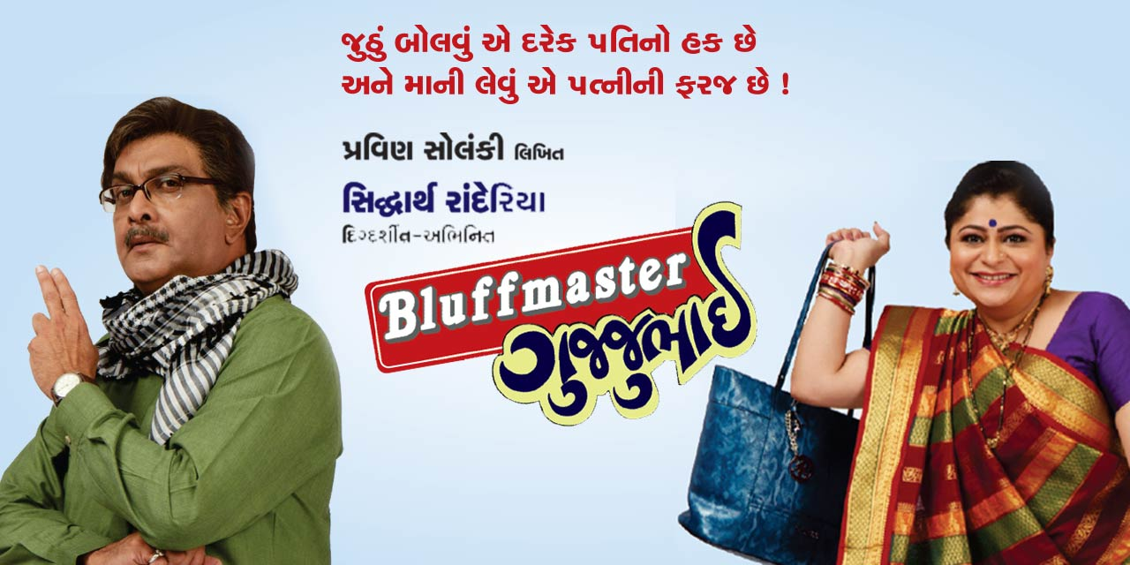
Artists : Siddharth Randeria , Tejal Vyas

Book my Show : https://in.bookmyshow.com/plays/bluffmaster-gujjubhai/ET00398436

Date: Wed 25 Mar 2026
Time: 9:30 PM
Duration: 2 hours 15 Min
Language: Gujarati
Place: Sanjeev Kumar Auditorium, Surat
Google Map link: https://maps.app.goo.gl/7TQukU6NBtq4EP7A9

About the event
A hilarious Laugh riot , again with Gujjubhai series, when an unknown girl comes at your house and immediately kisses Gujjubhai and his wife sees it? So what will happen now,let’s come together and enjoy the gujjubhai new play Bluffmaster Gujjubhai.

- Manoj Muntashir’s Krishna – Radhe Se Ranbhumi Tak
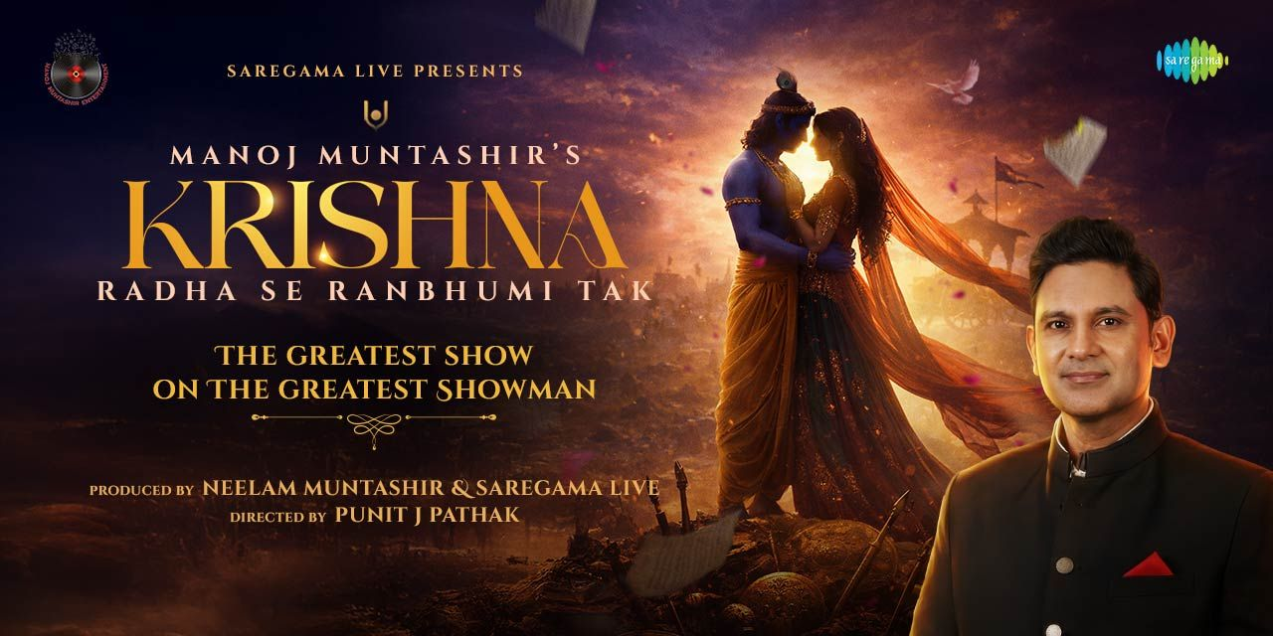
Artists: Manoj Muntashir
Book My Show: https://in.bookmyshow.com/plays/manoj-muntashir-krishna-radha-se-ranbhumi-tak/ET00490018
Date: 17 Apr 2026
Time: 7:30 pm
Duration: 2 hours 15 Min
Language: Hindi, English
Place: Sanjeev Kumar Auditorium, Surat
Google Map Link: https://maps.app.goo.gl/33H1ueLJqjMbTaeW8
About The Event
Manoj Muntashir's Krishna: Radha Se Ranbhumi Tak
Experience the story of Krishna like never before-beyond mythology, into emotion, philosophy, and purpose.
Narrated by Manoj Muntashir, this live theatrical spectacle traces Krishna's extraordinary journey from the tenderness of Radha's love to the thunder of the battlefield. Through powerful storytelling, soul-stirring music, and breathtaking stagecraft, the show unveils Krishna as a lover, a guide, and a master strategist-navigating prem, neeti aur yudh.
More than a narration, this is a cinematic, larger-than-life experience where words merge with music, and devotion rises into drama.
Profound yet deeply moving, intimate yet epic, the production brings alive the many shades of Krishna in a way that resonates with the heart and challenges the mind.
Directed by Puneet J. Pathak and created for devotees, families, theatre lovers, and audiences across generations, this is not just a performance-it is an unforgettable LIVE theatrical experience.
Truly, it's the greatest show, The Greatest Showman.

- Comedy:

- ‘Gujaratipanu’ by Amit Khuva

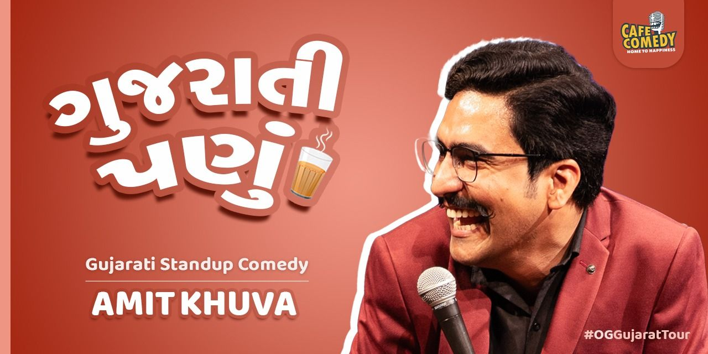

Artists: Amit Khuva

Book My Show: https://in.bookmyshow.com/events/gujaratipanu-by-amit-khuva/ET00488324

Date: 04 Apr 2026
Time: 8:00 pm
Duration: 1 hour 30 min
Language: Gujarati
Place: Osari, Surat
Google map link: https://maps.app.goo.gl/p8iinjH8tFEje85H6
About The Event

'Gujaratipanu' - Clean Gujarati Standup Comedy Special by Amit Khuva

Inspired by Gujju Life, From how we think, behave & speak to our family moments, social behavior, and gujju opinions;

Amit brings all these in his new special to the stage with sharp observations and natural humor.

In short, the show captures the 'Gujarati Ni Asli Vibe' we all know so well.
You'll laugh, relate, and say, "Aapne Pan Aavu J Karie Chhie!"
Haji vaanchvu chhe? Book Karido Vhala! Malie Show Ma.

- Dalaliyo – Gujarati Comady Show By Haardik Butani
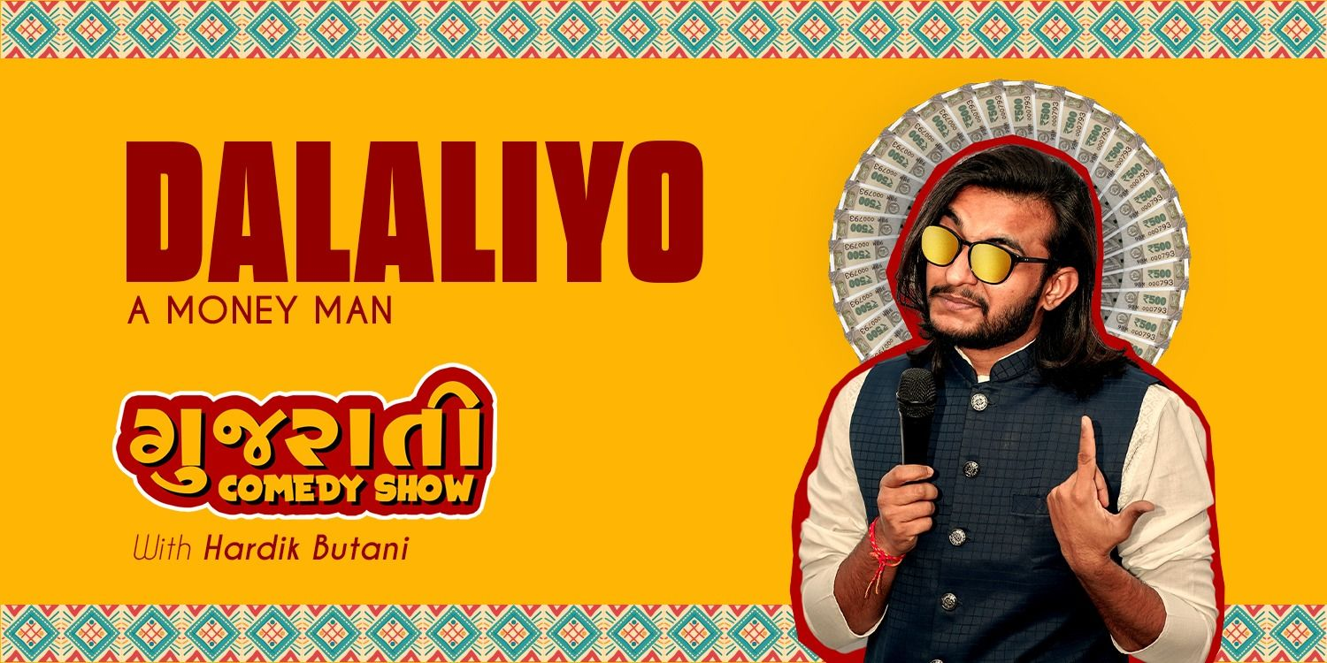

Artists: Haardik Butani
Book My Show: https://in.bookmyshow.com/events/dalaliyo-a-money-men-with-hardik-butani/ET00480849
Date: 18 Apr 2026
Time: 9:00 pm
Duration: 1 hour 15 min
Language: Gujarati
Place: The Green Room, Surat
Google Map link: https://maps.app.goo.gl/AwVaVtYh8Lwz58o3A
About The Event
Hardik Butani is a Kathiawadi stand-up comedian known for his raw, relatable, and laughter-packed storytelling. He has performed in numerous local desi dayras and is the founder and creator of the hit comedy show UBHO DAYRO.
For the past 5 years, Hardik has been successfully performing UBHO DAYRO across Gujarat, making it one of the first-ever Kathiawadi stand-up comedy formats in the state.
The show is filled with hilarious village life stories, household politics, desi culture, and real-life Kathiawadi humor that audiences instantly connect with. Every performance is high on energy, authenticity, and nonstop laughter.
Note: This show contains 18+ content.
Come, experience Kathiawadi comedy like never before - UBHO DAYRO promises a night full of laughter and desi vibes!

- Kal ki Chinta Nahi Karta ft. Ravi Gupta
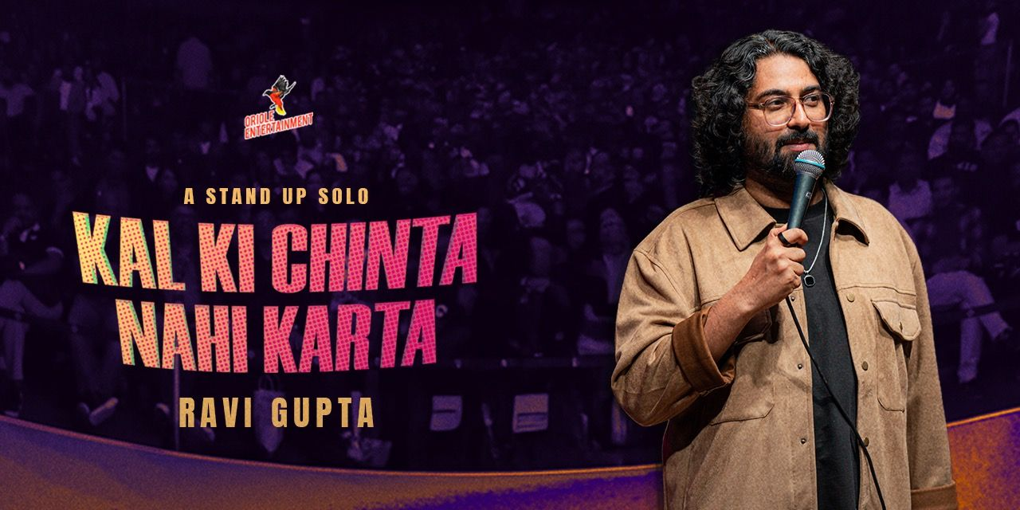
Artists: Ravi Gupta
Book My Show: https://in.bookmyshow.com/events/kal-ki-chinta-nahi-karta-ft-ravi-gupta/ET00329412
Date: 10 May 2026
Time: 7:30 PM
Duration: 1 hour 15 Min
Language: hindi
Place : Sanjeev Kumar Auditorium, Surat
Google Map Link: https://maps.app.goo.gl/iAJ8qqhC7rTwRBqC9
About The Event
Forget your Kal ki Chinta and Join us in this super funny Show by Ravi Gupta. Kal Ki Chinta Nahi Karta is new stand up special by Ravi Gupta.

- Harsh’O’Ulas ft. Harsh Gujral
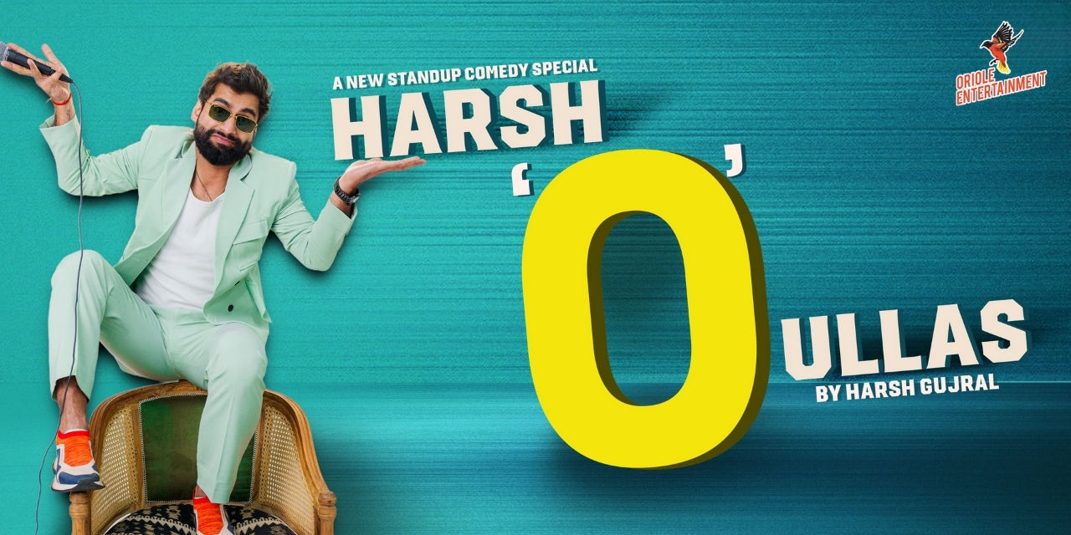
Artists: Harsh Gujral
Book My Show: https://in.bookmyshow.com/events/harsh-gujral-live/ET00461660
Date: 24 May 2026
Time: 8:00 pm
Duration: 1 hour 30 Min
Language: English, Hindi
Place: Sanjeev Kumar Auditorium, Surat
Google Map link: https://maps.app.goo.gl/iAJ8qqhC7rTwRBqC9
About The Event
Harsh Gujral is a renowned Indian stand-up comedian and content creator, celebrated for his acclaimed show Jo Bolta Hai Wohi Hota Hai. Known for his authentic style and dynamic performances, he has captivated audiences across India and globally, including in the United States, United Kingdom, and Australia.

- Workshops/Activity :

- Acting Karoge Kya? – Kids Edition
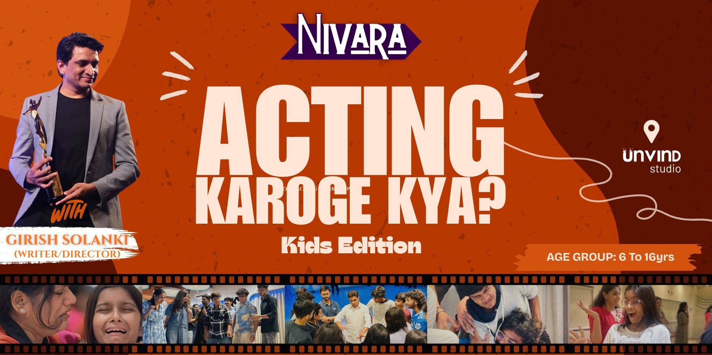
Book My Show: https://in.bookmyshow.com/events/acting-karoge-kya-kids-edition/ET00490615
Date: Sun 22 Mar 2026
Time: 5:00 pm
Duration: 2 Hours
Language: Hindi, English
Place: Unvind Studio, Surat
Google Map link: https://maps.app.goo.gl/J8YgB1nffZypc8Fx6
About The Event
A fun and engaging 2-hour acting workshop specially designed for kids who love performing, storytelling, and expressing themselves. This session introduces young participants to the basics of acting, expression, imagination, and stage confidence through interactive theatre exercises and games.
Whether your child is curious about acting, enjoys drama activities, or simply wants to explore creativity, Acting Karoge Kya? Kids Edition is the perfect starting point.
The workshop will be conducted by Girish Solanki (Writer / Director), who has worked extensively in theatre and performance training with 22+ Years of Experience.

- Pencil Power Drawing Competiton (PPDC) – Online
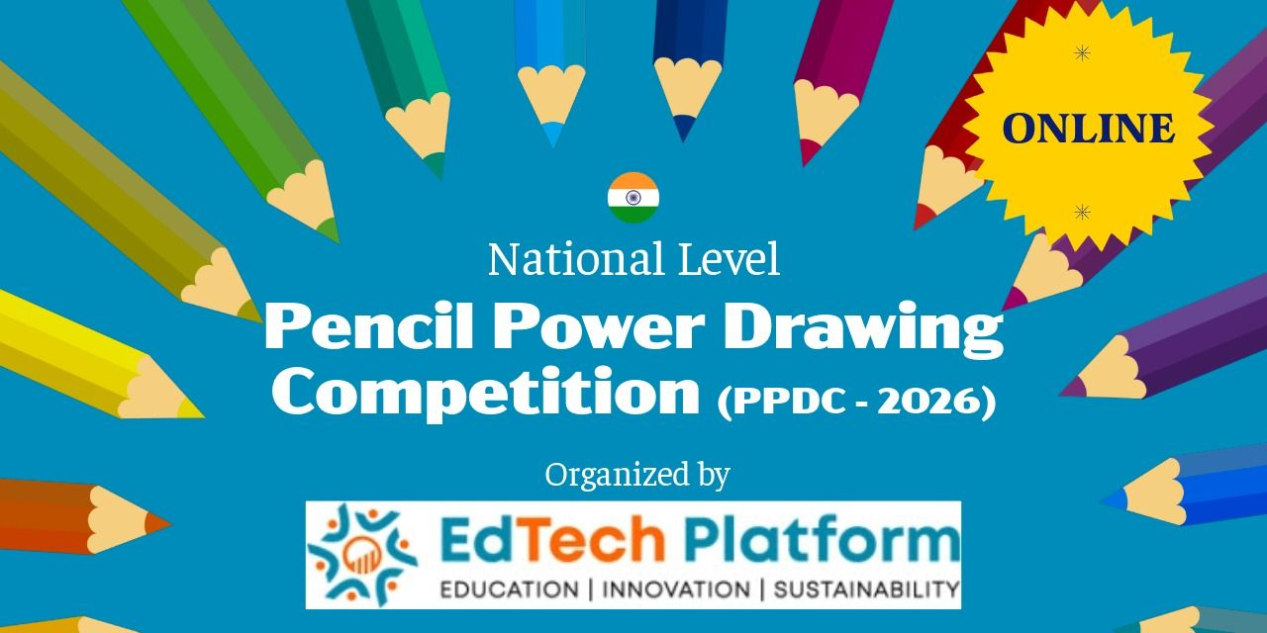
Book My Show: https://in.bookmyshow.com/events/pencil-power-drawing-competition-ppdc-online/ET00485265
Date: Wed 20 May 2026
Time: 12:30 pm
Duration: 1 hour
Place : Venue To Be Announced – Surat
About The Event
Online* Summer Event - Read instructions
before applying
Pencil Power Drawing Competition (PPDC) -2026
This prestigious competition offers a chance to prove your skills, win medals, gain national recognition, and grab exciting cash rewards!
Guidelines for Participation:
1. Register and pay the fees for single artwork.
2. The joining link will be sent to your registered email/mobile in next 2-3 working days.
3. Join the Drawing Olympiad (PPDC) - 2026 through the platform specified by the organizer.
Or more details, search Pencil Power Drawing Competition on BookMyShow / Google.

4. Music
1. Usha Uthup Live in Surat
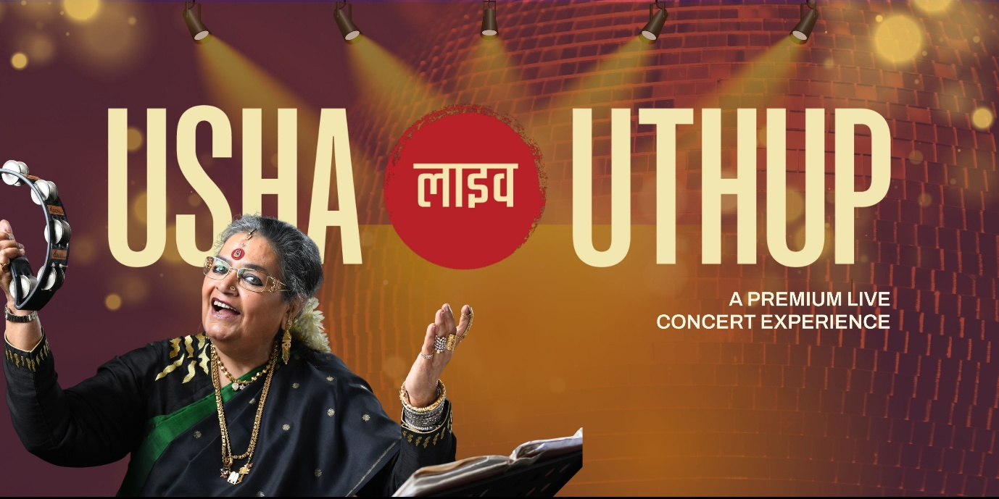
Artists: Usha Uthup
Book My Show: https://in.bookmyshow.com/events/usha-uthup-live-in-surat/ET00491565
Date: Sat 4 Apr 2026
Time: 7:00 pm
Duration: 3 Hours
Language: Hindi
Place: Jamnba Party Plot and Lawn, Surat
Google Map Link: https://maps.app.goo.gl/btyza1aQ9Snk3FCc6
About The Event
Get ready, Surat! The iconic voice that defined generations is coming live.
Usha Uthup takes the stage for an unforgettable evening filled with timeless hits, electrifying energy, and pure nostalgia. From disco classics to soulful melodies, experience the charisma and powerhouse vocals of India's original pop sensation like never before.
Whether you grew up with her music or discovered her vibe recently, this is a night for every generation to sing, dance, and celebrate together.
2. Times Live with Backsatge Siblings – Surat


Book My Show: https://in.bookmyshow.com/events/times-live-with-backstage-siblings-surat/ET00488576
Date: Sat 21 Mar 2026
Time: 6:00 pm
Duration: 1 Hour 30 Min
Language: Hindi
Place: Pandit Dindayal Upadhyay Indoor Stadium, Surat
Google Map Link: https://maps.app.goo.gl/LCeBeey2zsmxLkw1A
About The Event
Get ready, Surat!!
It's time to create history with the 1st ever Backstage Sibling show ft. Saahil live in Surat. 21st March, Pandit Dindayal Upadhyay Indoor Stadium, Surat
Backstage Siblings is an Indian brother-sister musical duo, Raghav (Musician) and Prachi (Musician), famous for creating immersive, community-focused jamming sessions that bring people together through music, often featuring Bollywood hits, spiritual bhajans, and organic experiences that focus purely on musical connection. They started from their living room and grew into India's largest jamming events, building a massive online following and performing for thousands.

